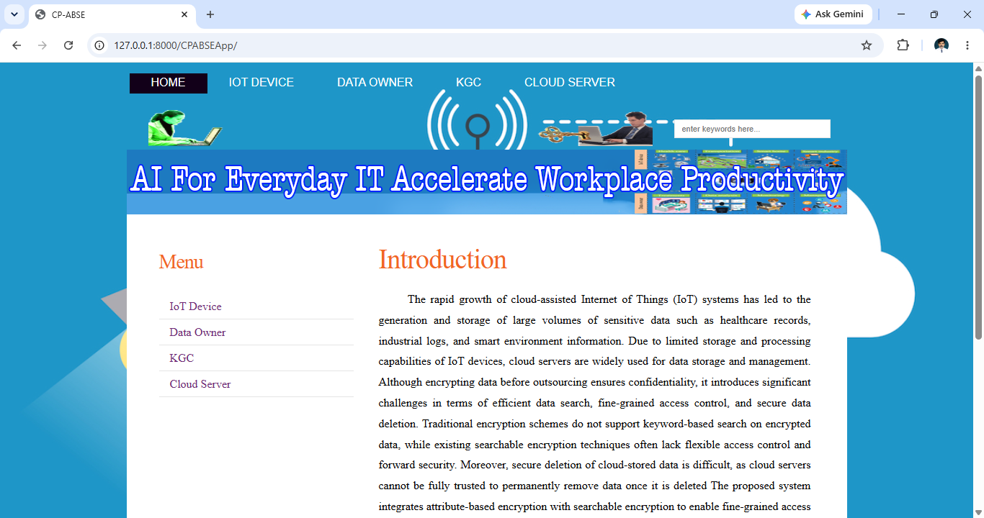
Iot device side
Register
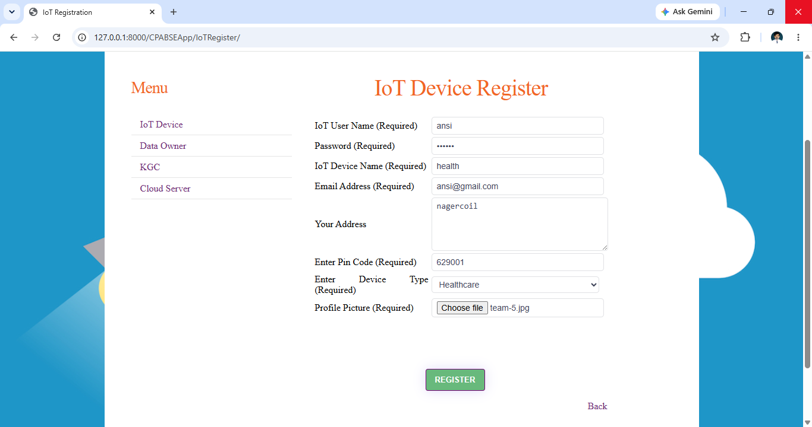

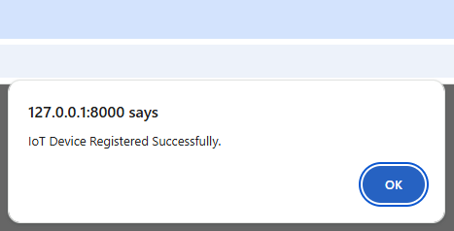
Iot device login
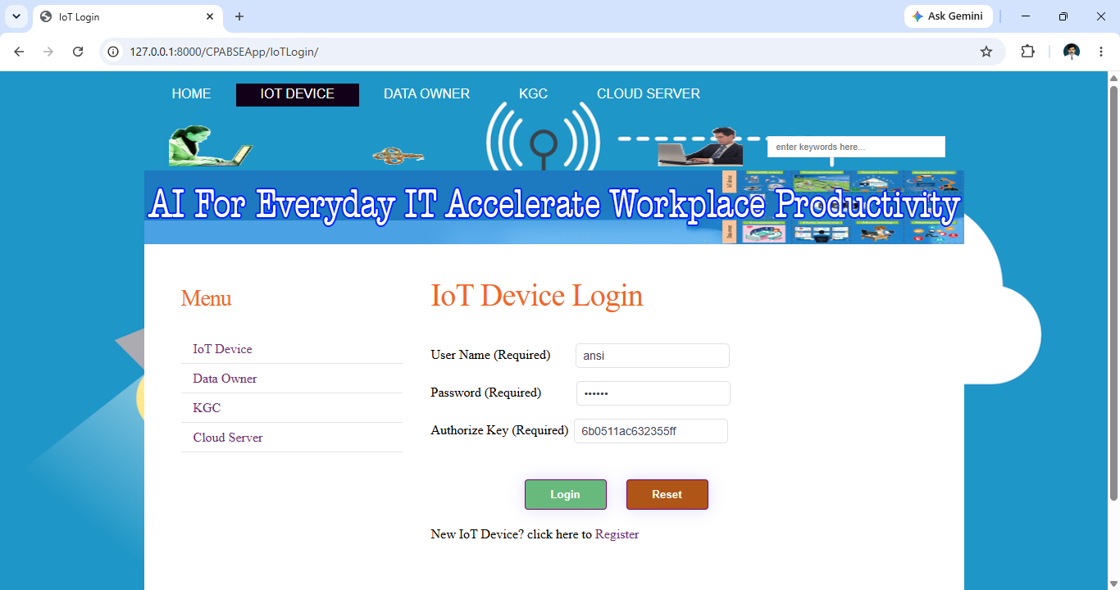
Iot device home
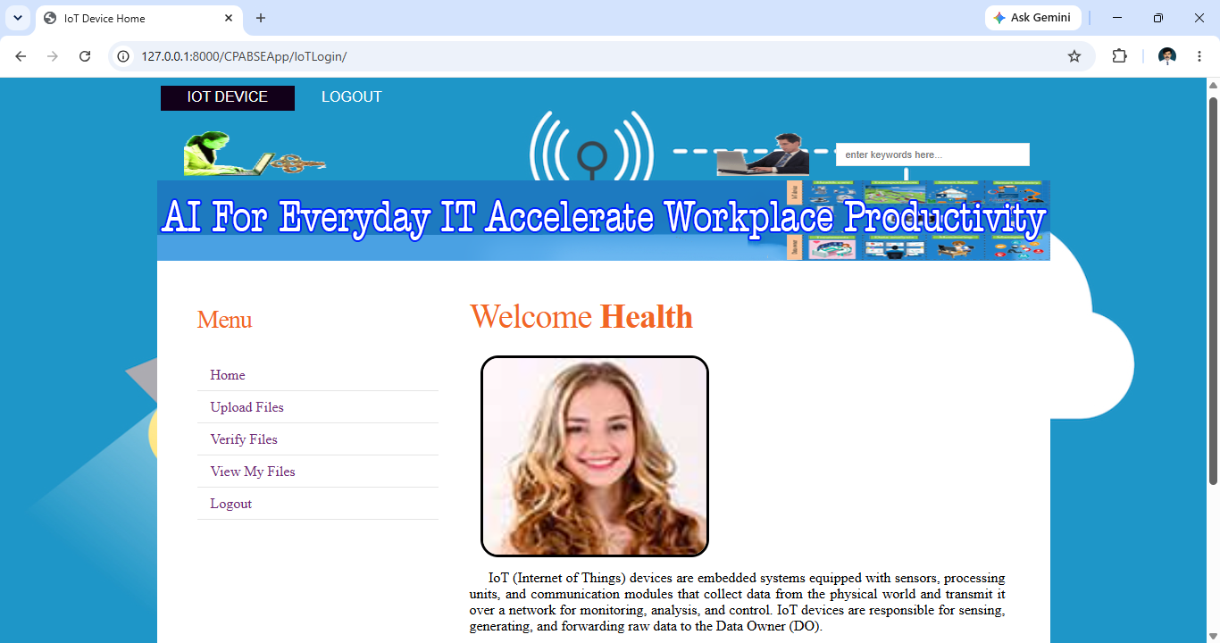
Upload file
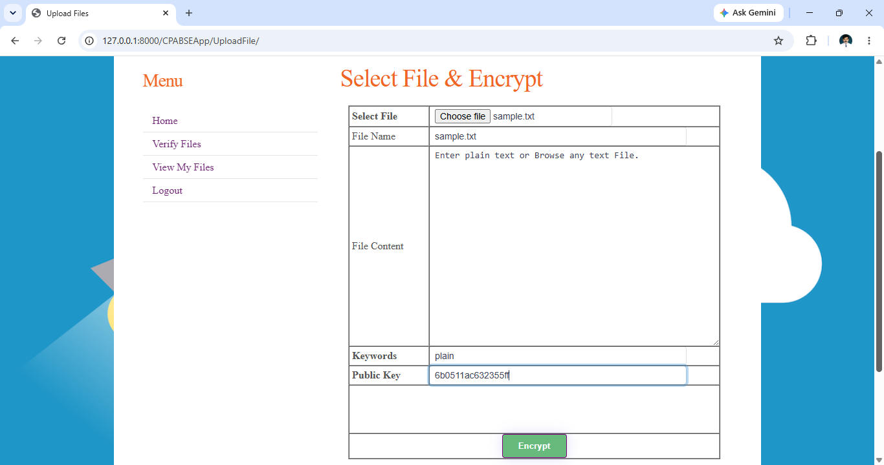
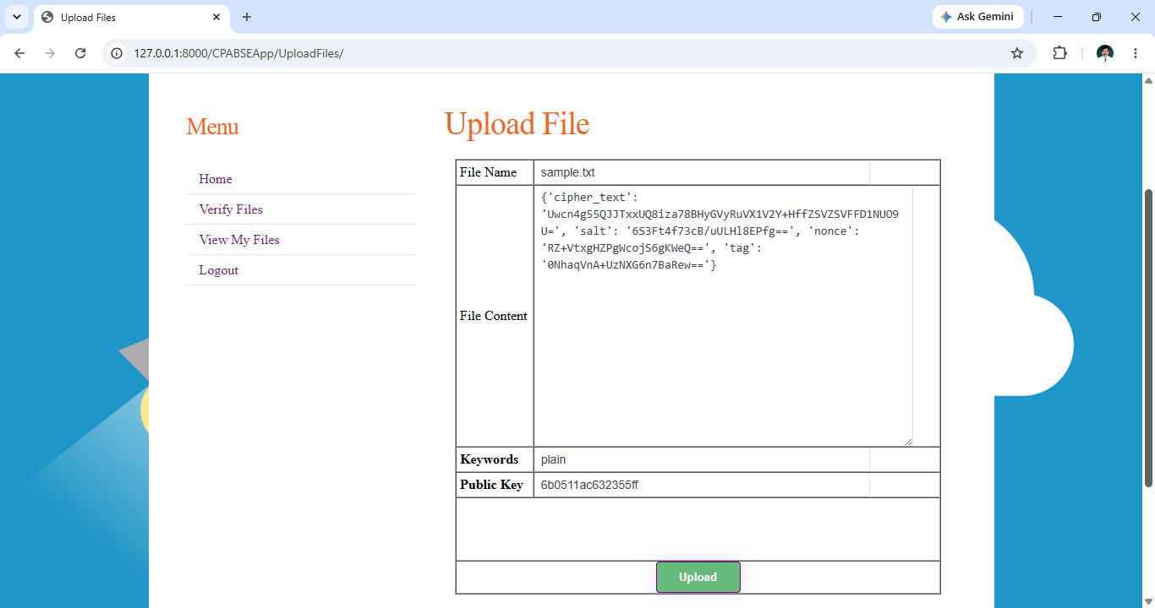

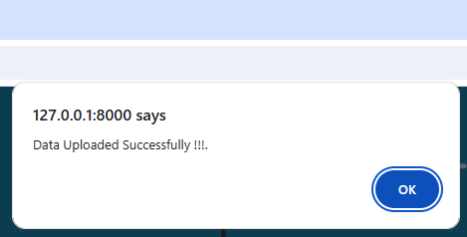
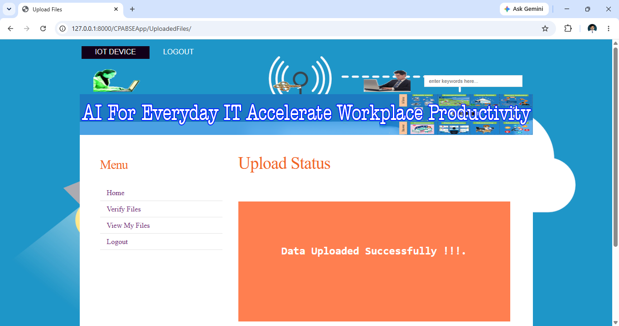
Verify Files
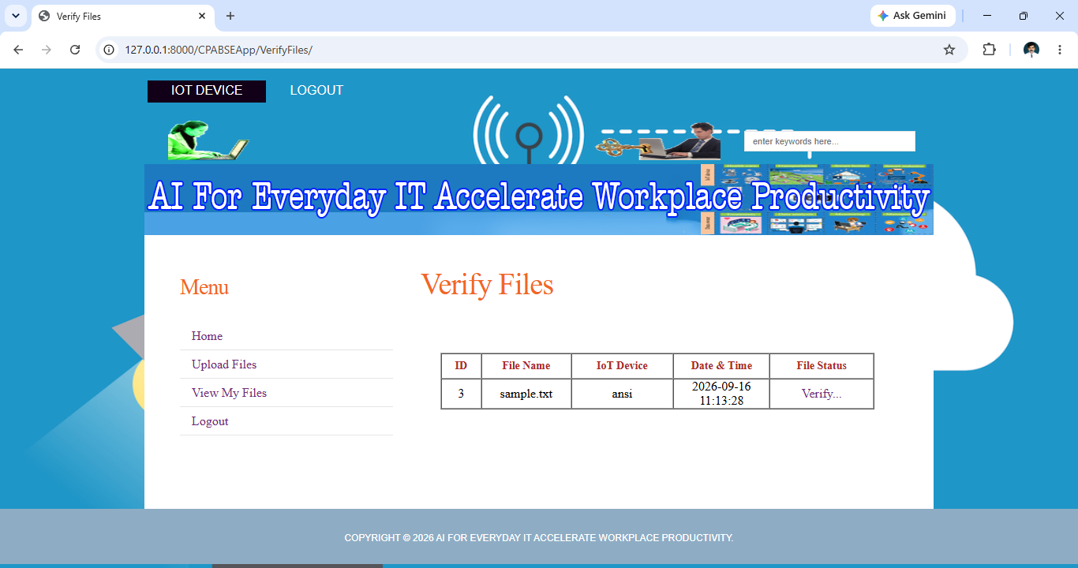
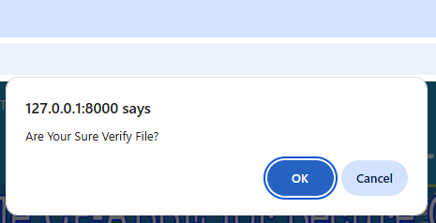
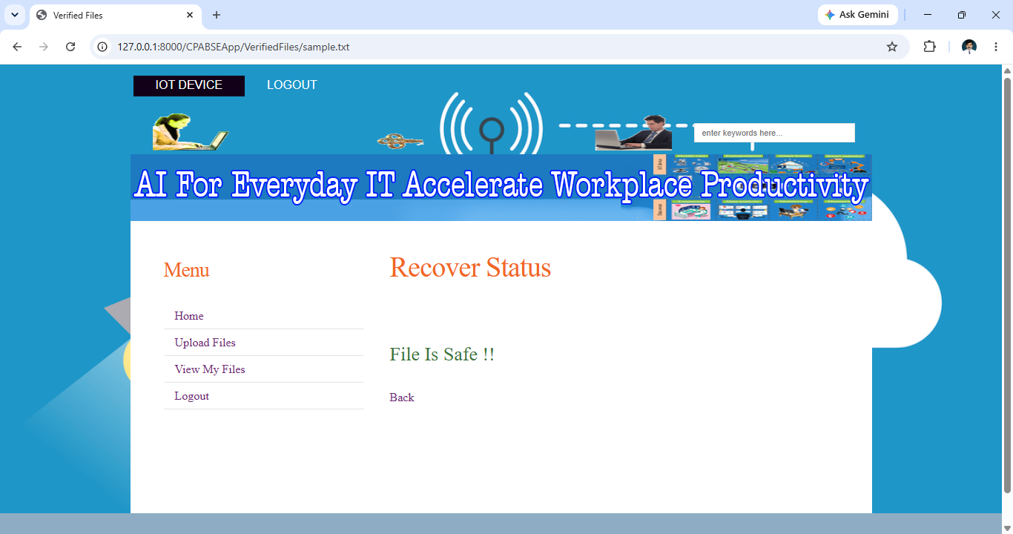
View Files
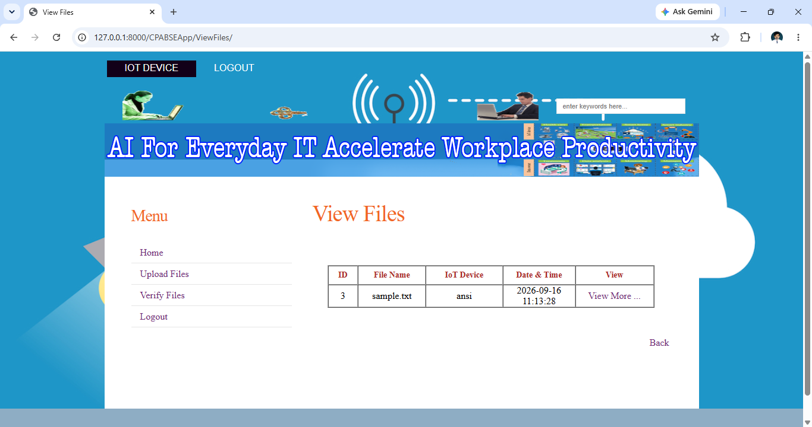
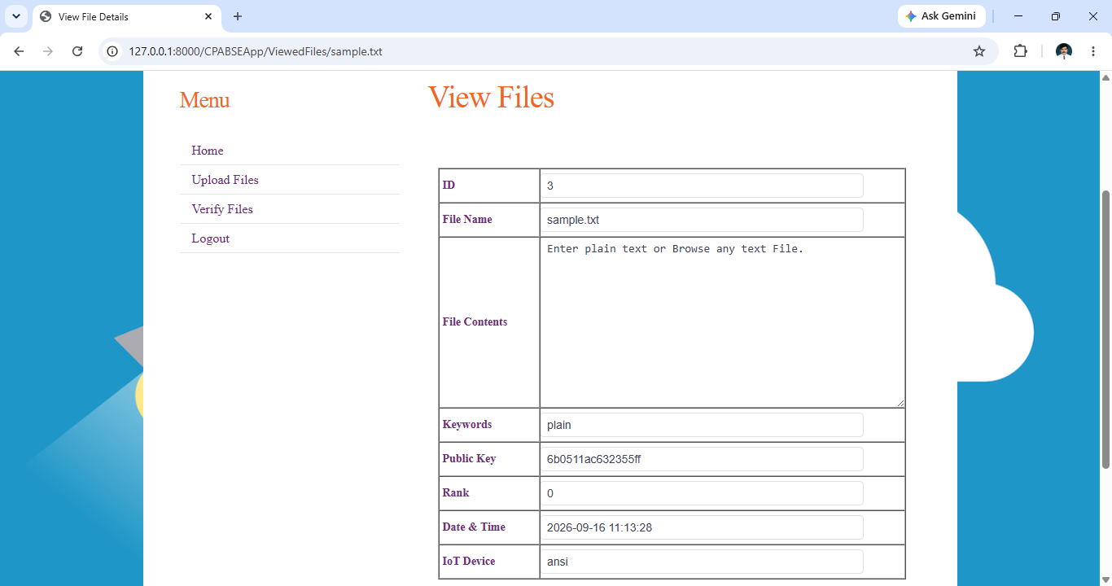

Data owner side
Owner register
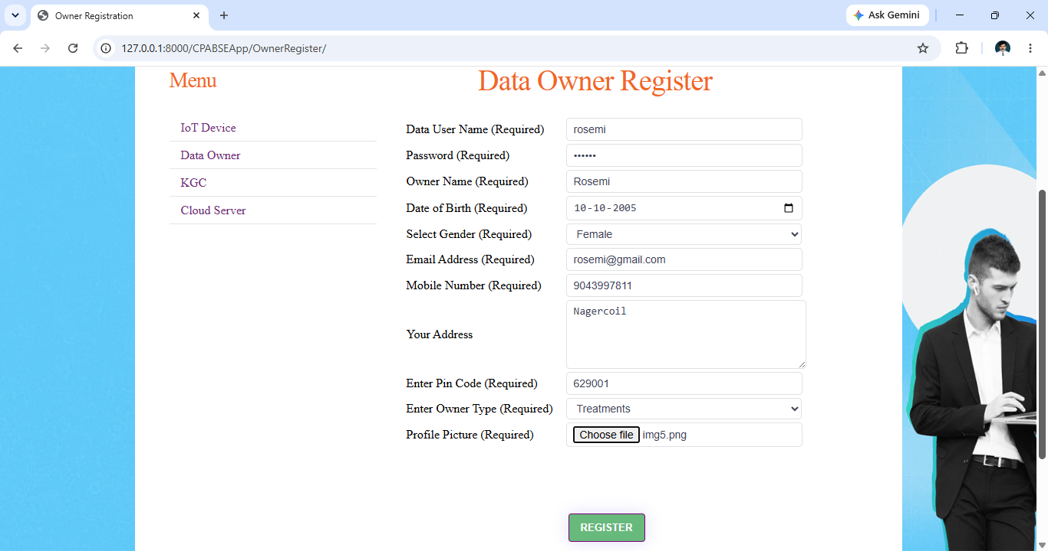

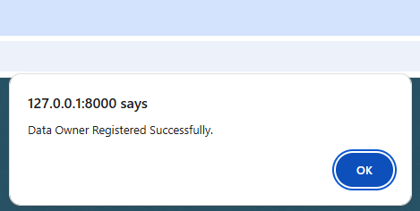
Owner login
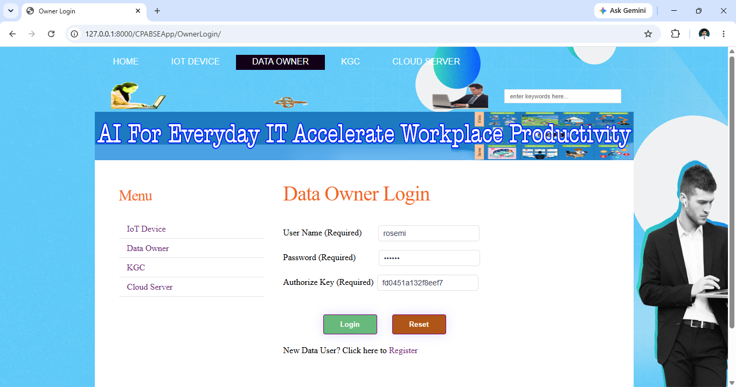
Owner home
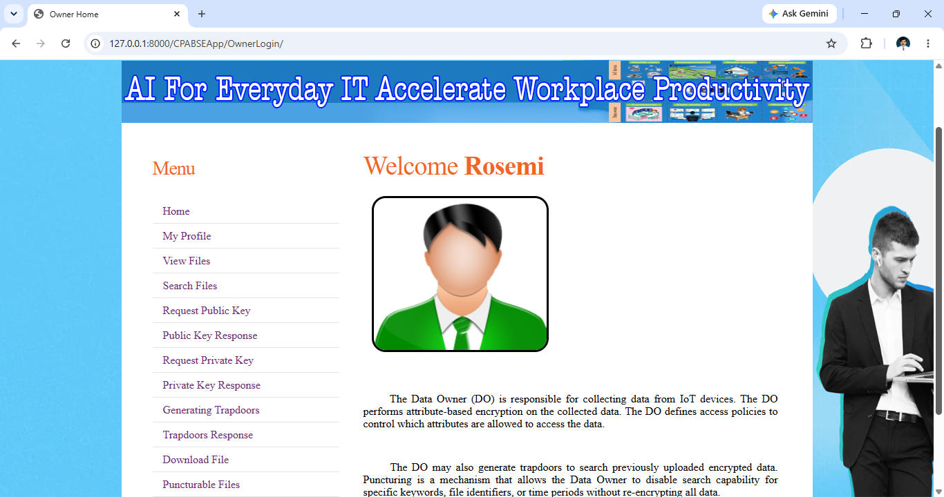
Owner profile
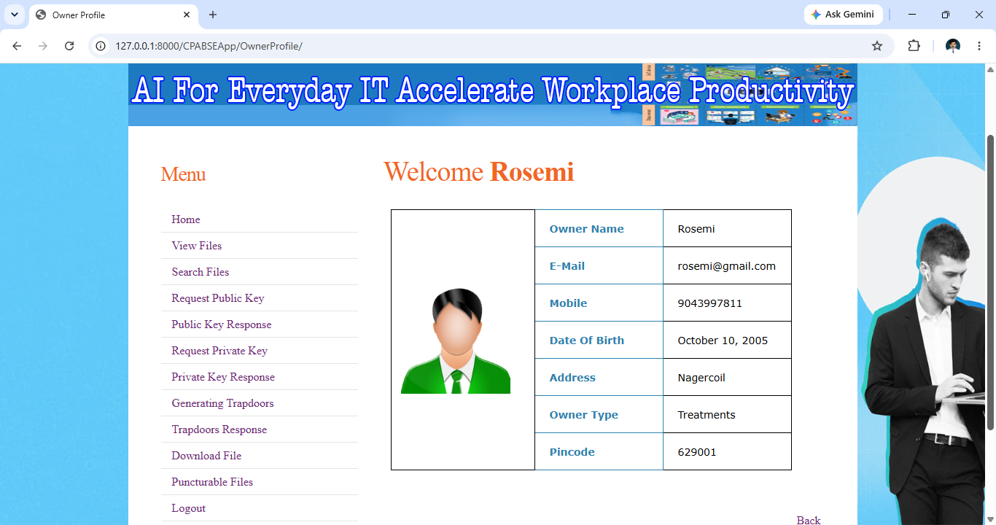
View Owner Files
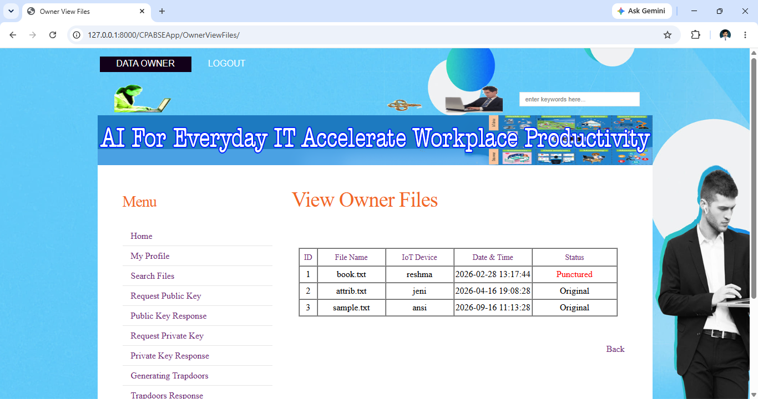
Search file
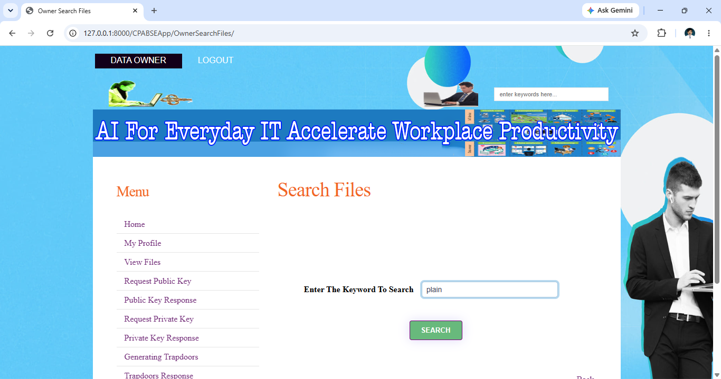

Request Private Key
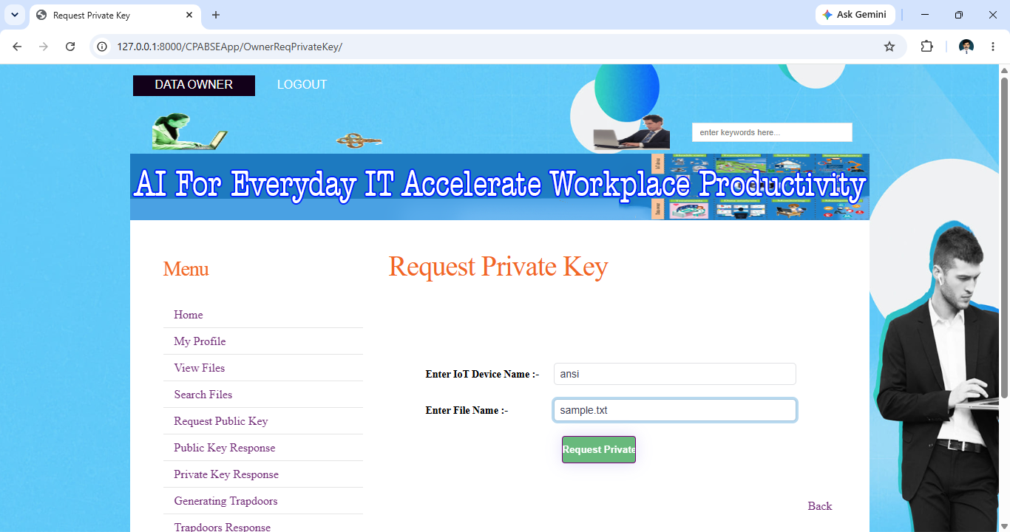
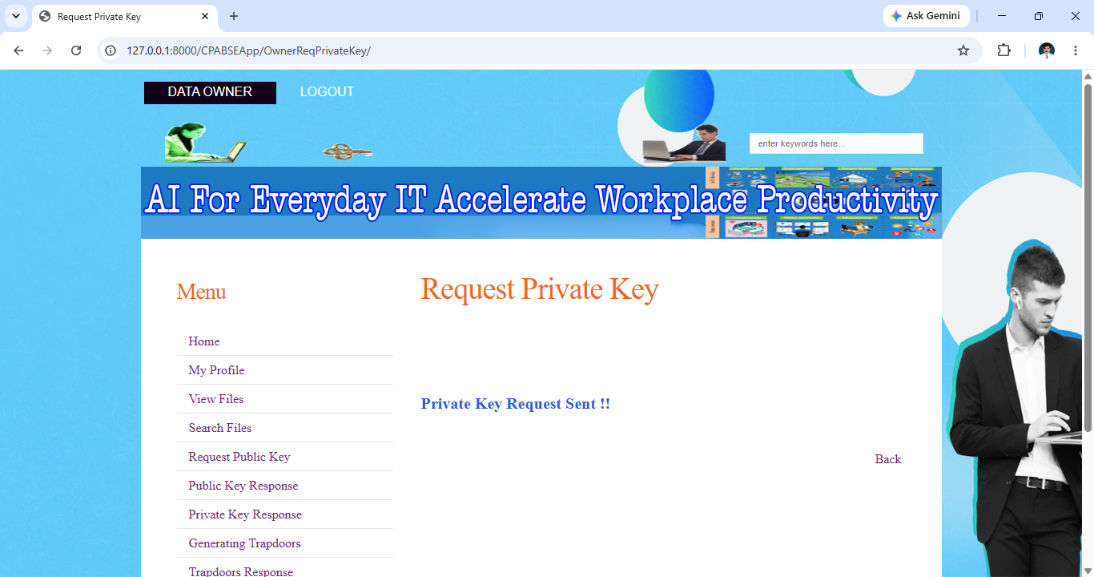
Response Private Key
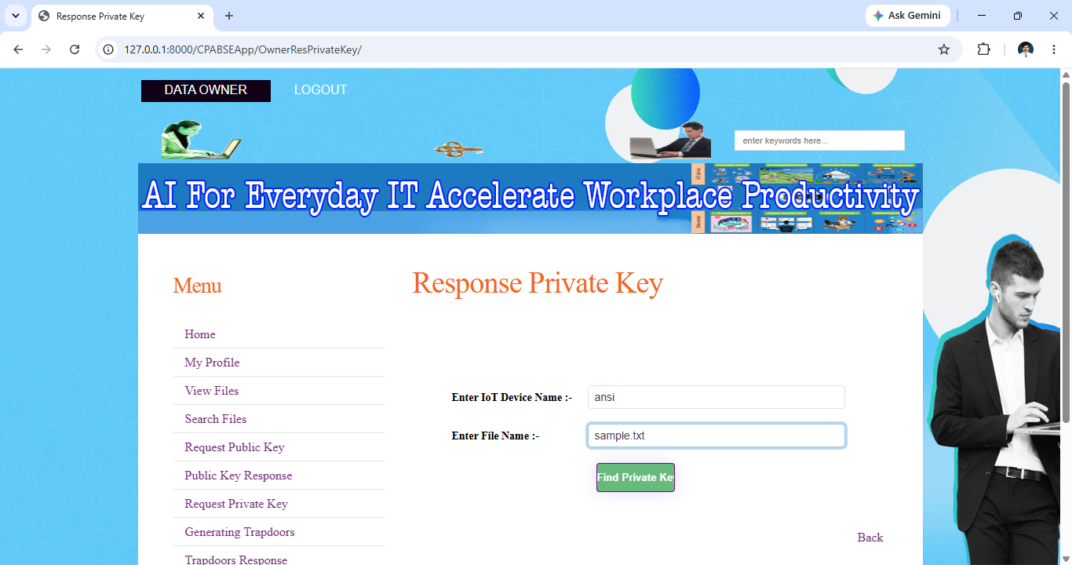
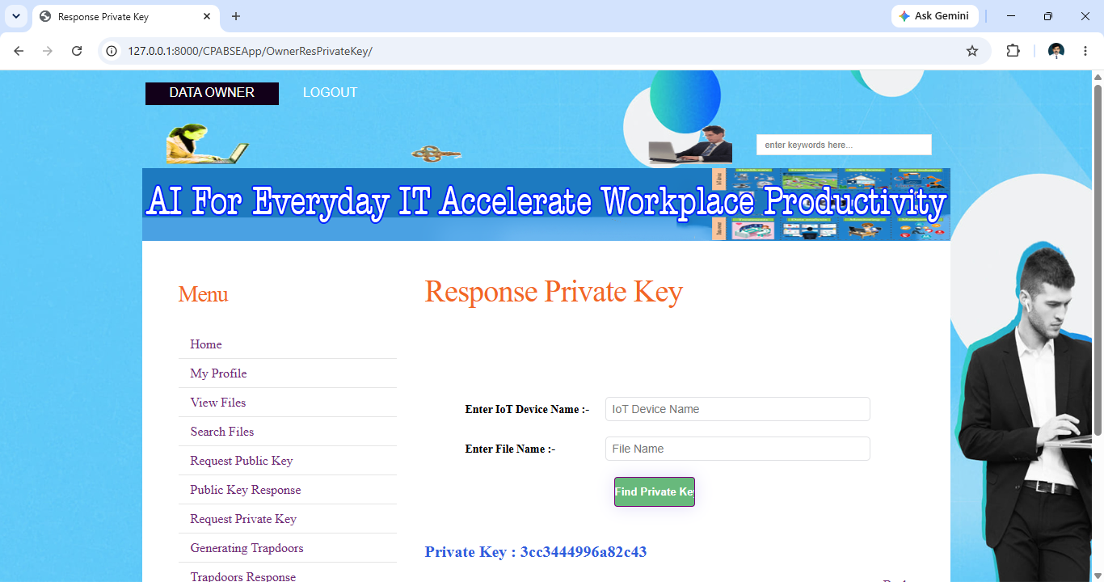
Download file
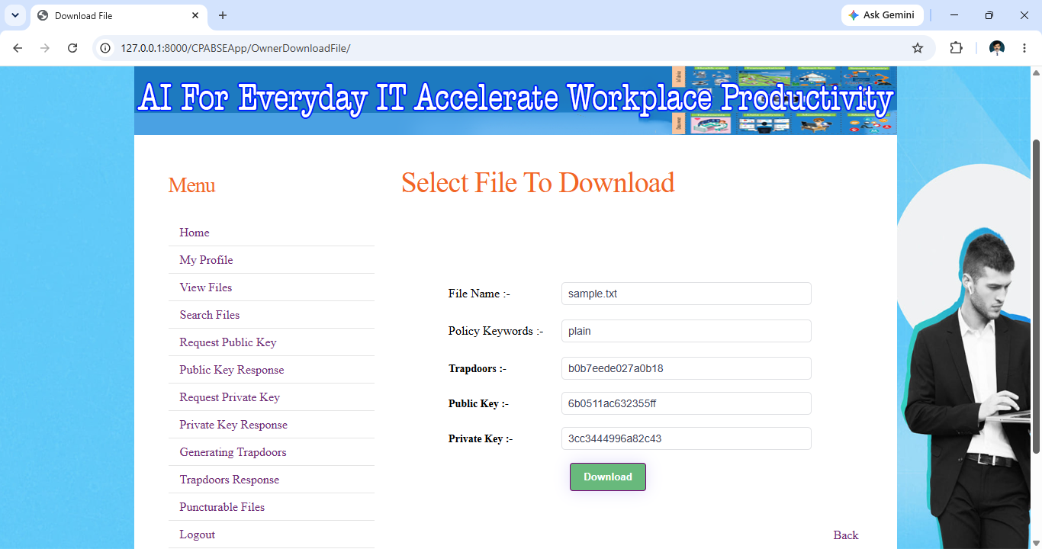
Downloaded file
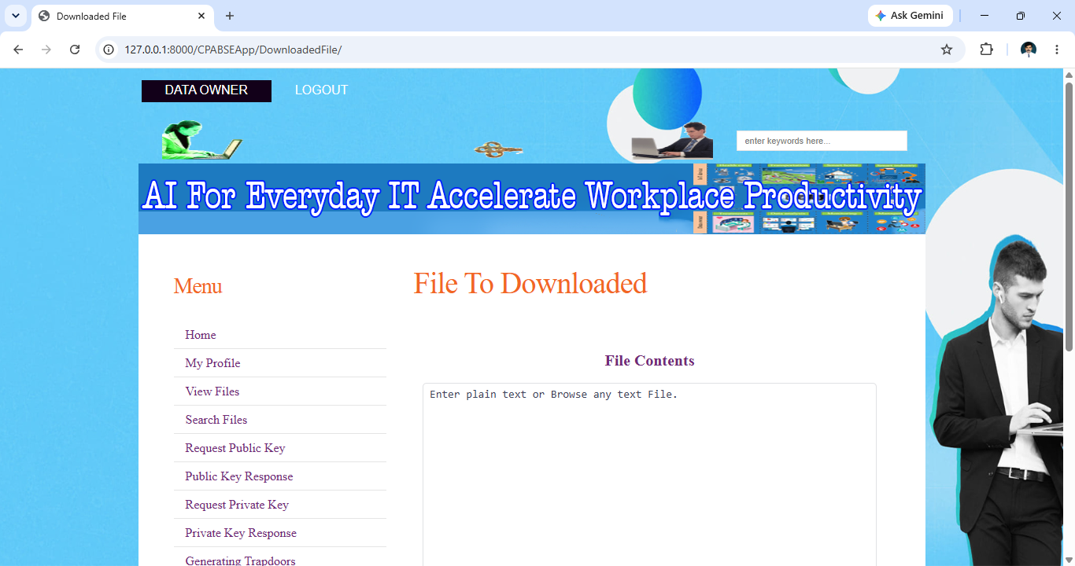
Puncturable Files
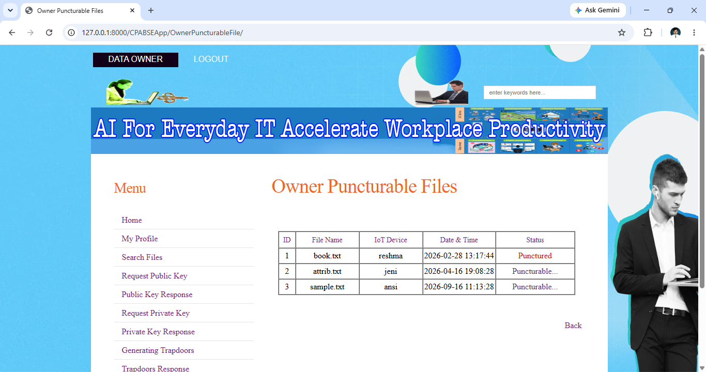

Kgc side
Kgc login
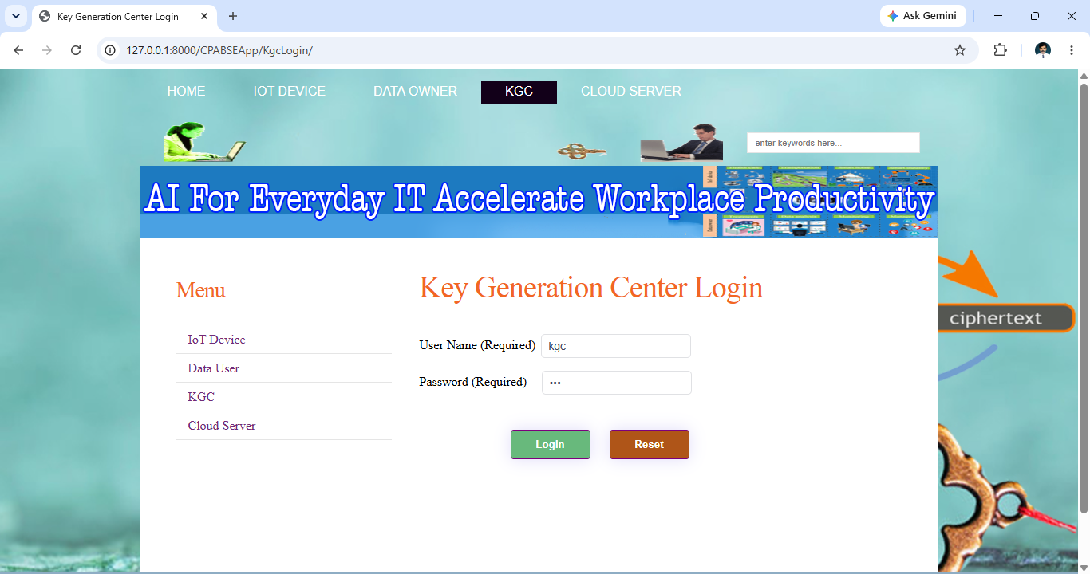
Kgc home
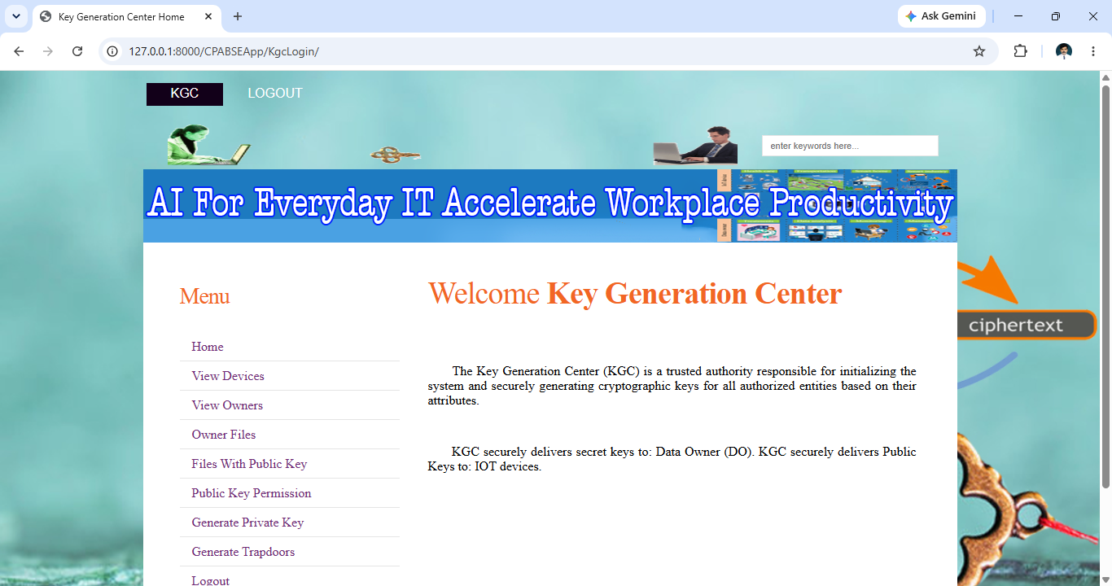
Device activate
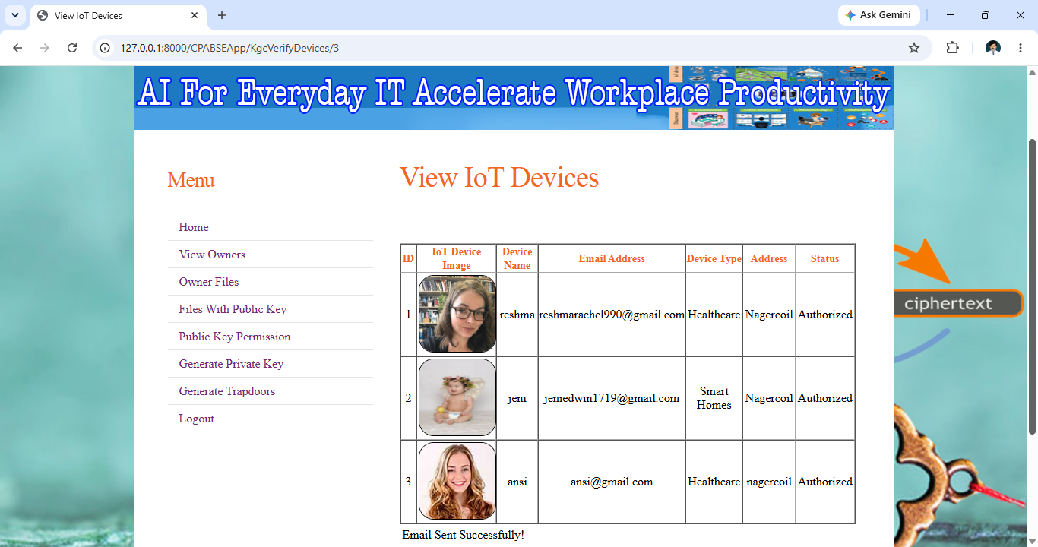

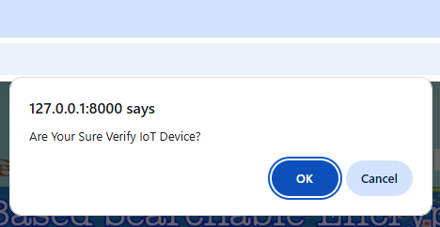

Data owner activate
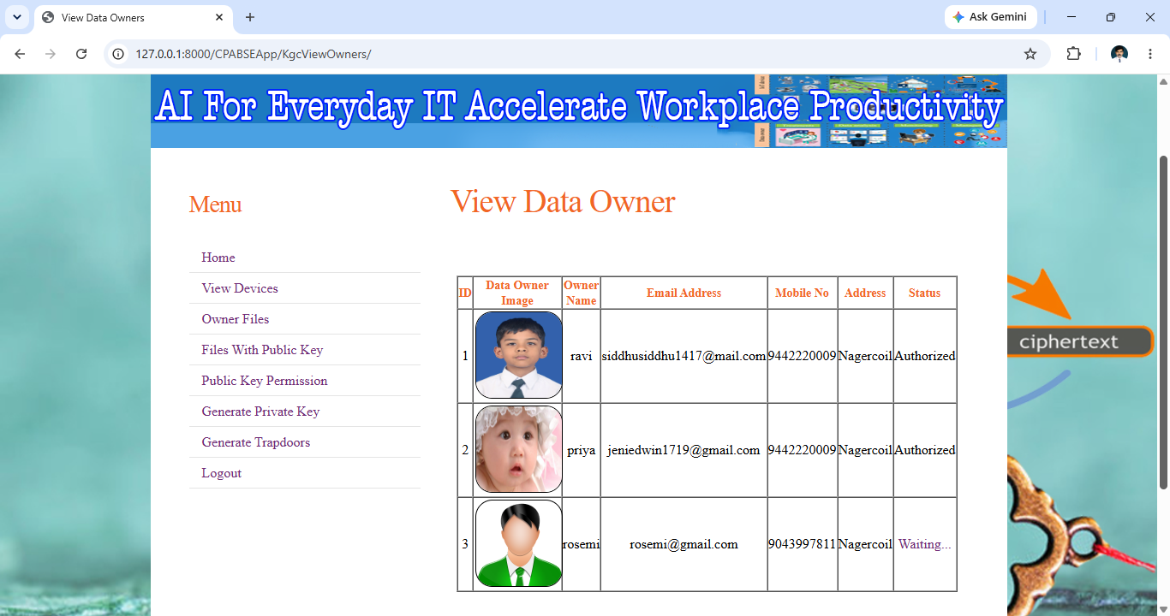

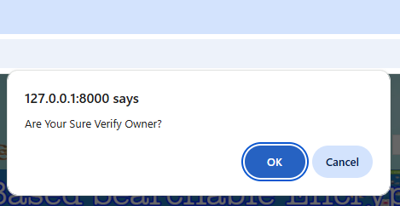
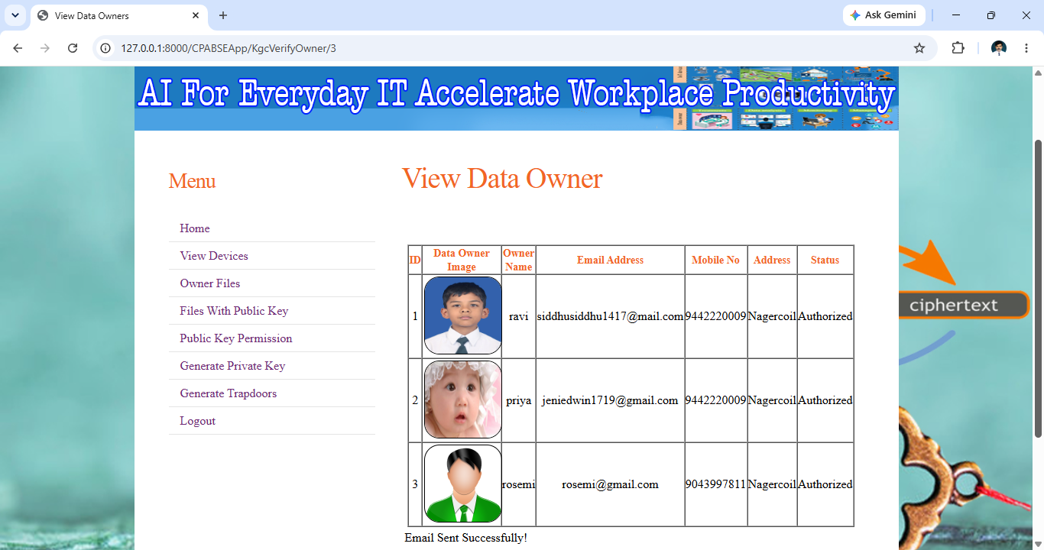
View owner files
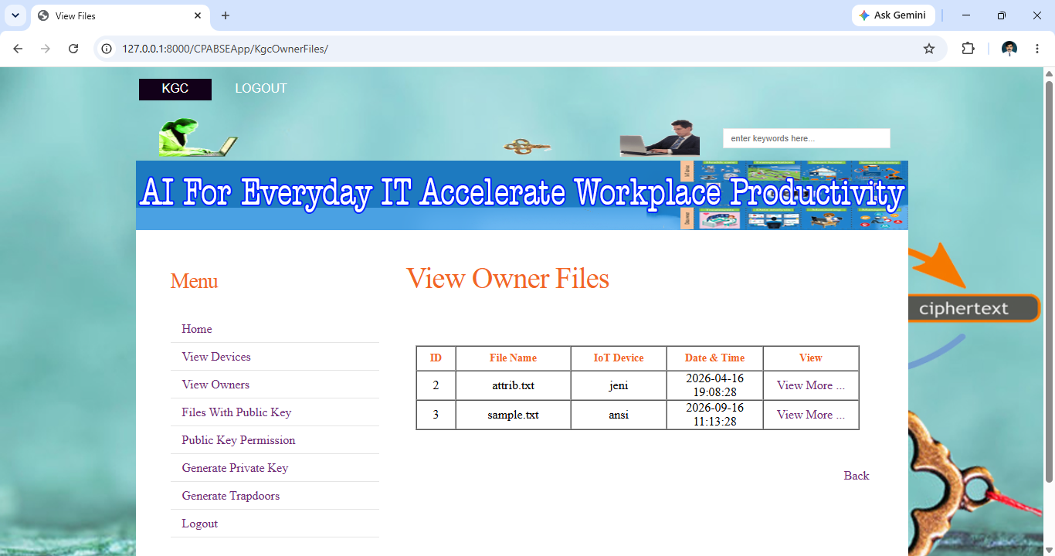
Generate Private Key
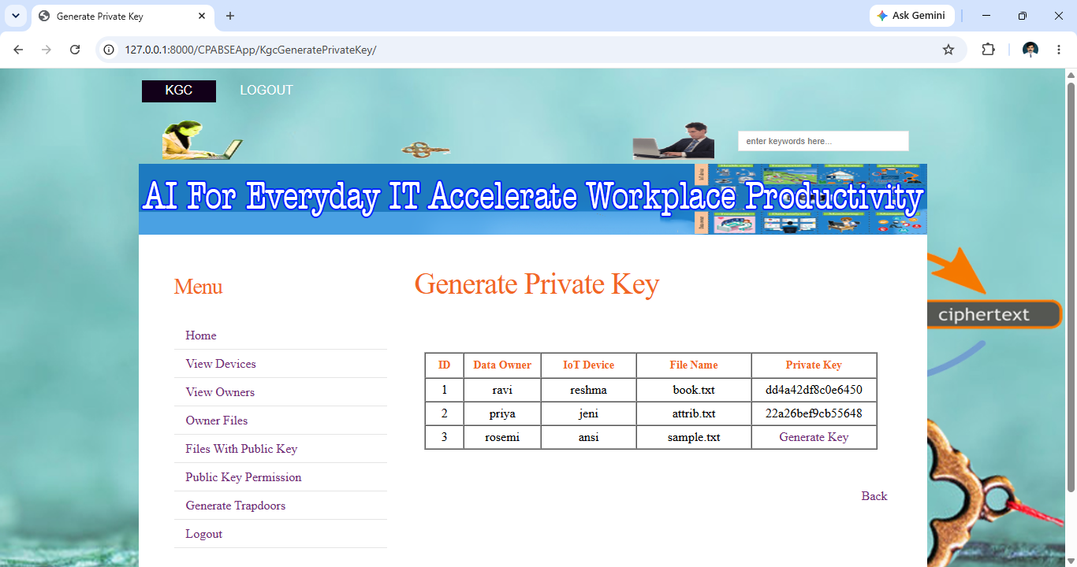
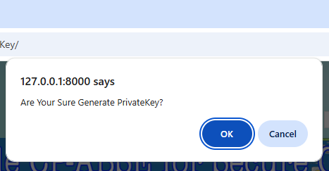
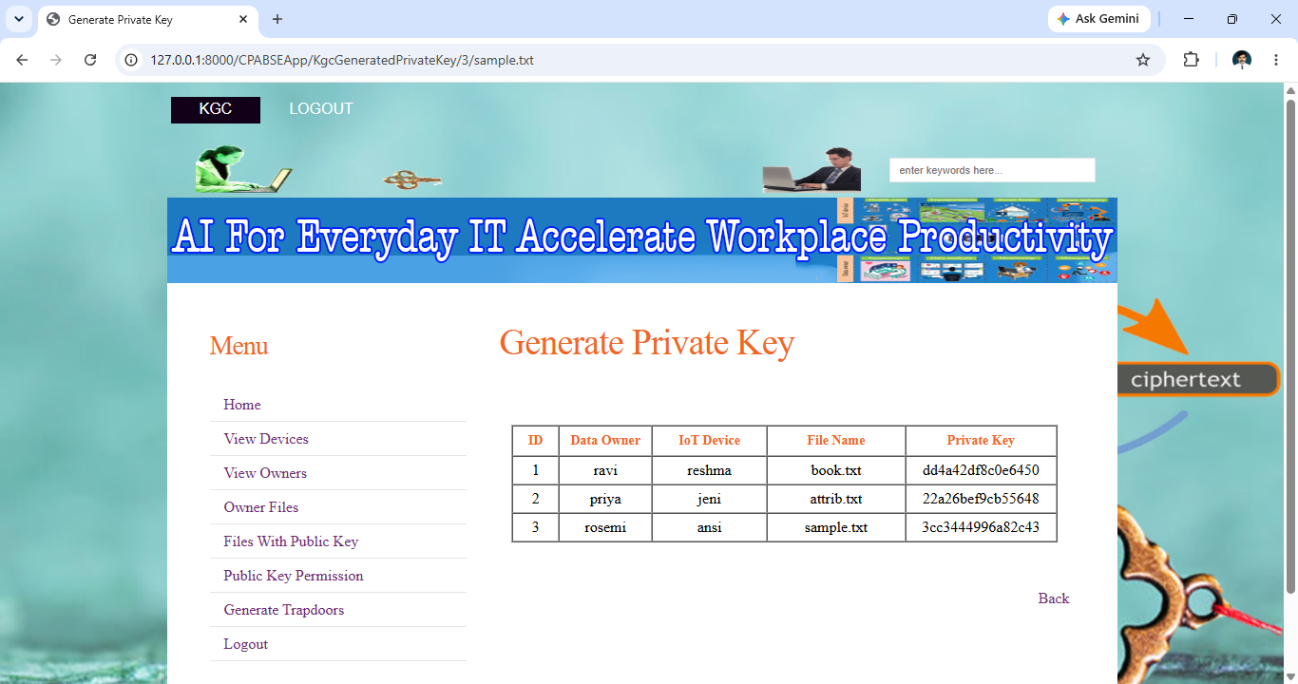

Cloud server side
Cloud server login
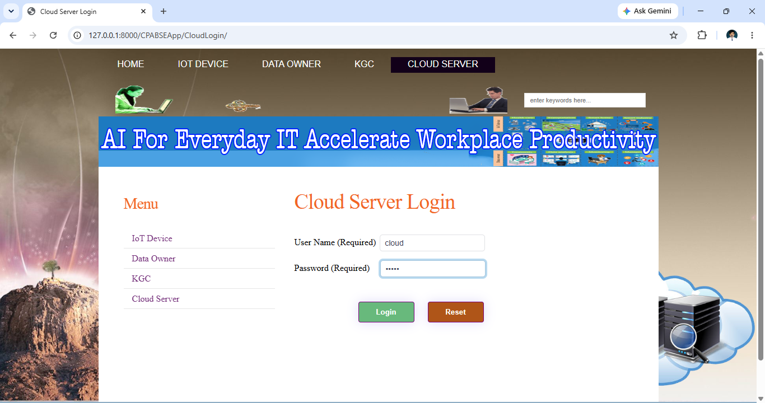
Cloud server home
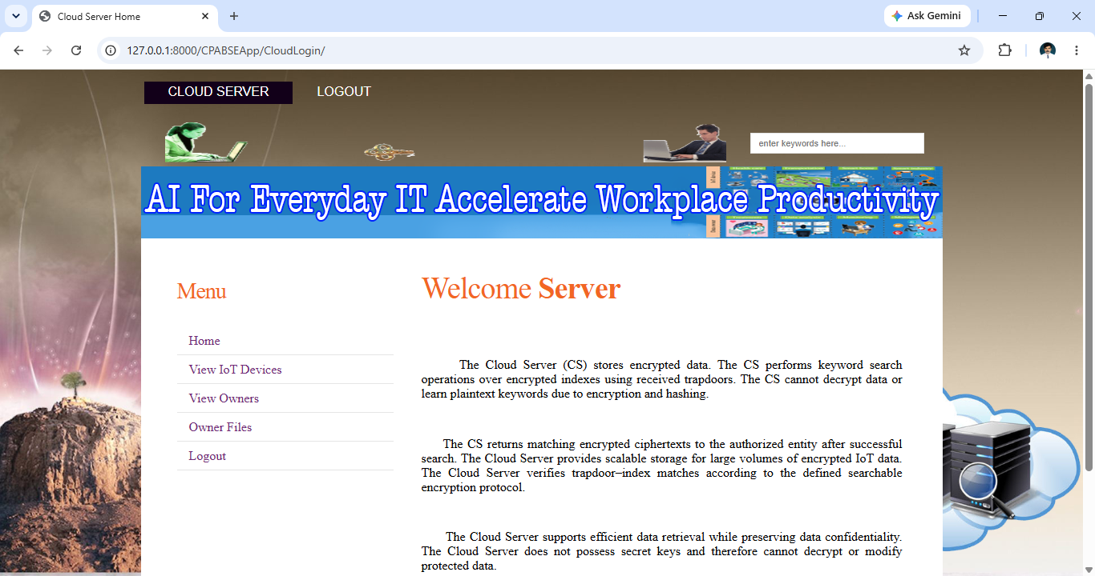
Owner details
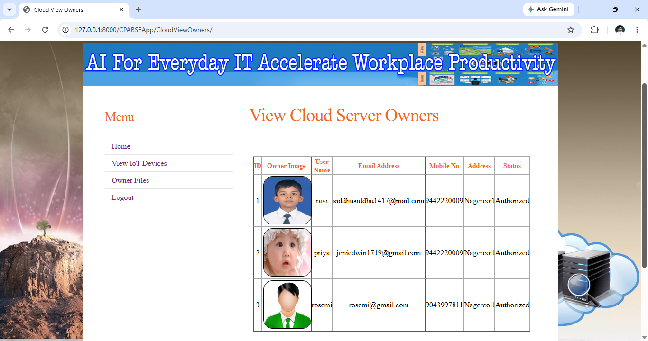
View owner files
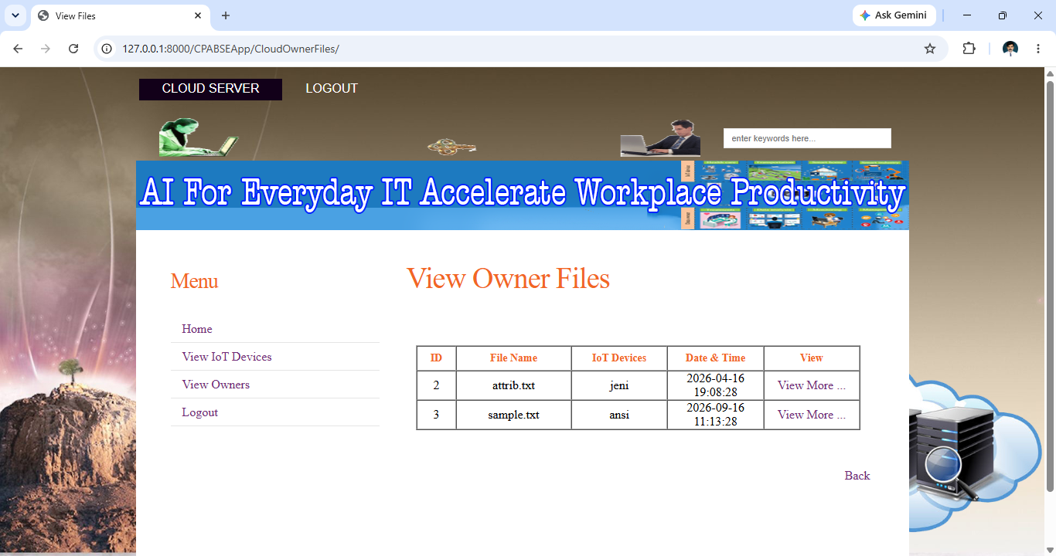

Source code
Views.py
import os
import ast
import codecs
import random
import hashlib
import datetime
import pyaes, pbkdf2, binascii, secrets
from re import search
from datetime import datetime
from .sendmail import sendmail
from .models import IoTDevices
from .models import Transaction
from .models import KGC
from .models import CloudServer
from .models import Search
from .models import KeyRequest
from .models import IoTDeviceFiles
from .models import OwnerRegistration
from .models import DataStorage
from .models import IOTKeys
from .models import Attacker
from django.db.models import Q
from django.db.models import Max
from django.contrib import messages
from django.shortcuts import render
from django.http import HttpResponse
from django.http import JsonResponse
from base64 import b64encode, b64decode
from Cryptodome.Cipher import AES
from Cryptodome.Random import get_random_bytes
from django.core.files.storage import FileSystemStorage

BASE_DIR = os.path.dirname(os.path.dirname(os.path.abspath(__file__)))

# Create your views here.
def index(request):
return render(request, "CPABSEApp/index.html")

def owner_register(request):
if request.method == "POST":
username = request.POST["userid"]
pwd = request.POST["pass"]
uname = request.POST["uname"]
dob = request.POST["dob"]
gender = request.POST["gender"]
email = request.POST["email"]
mobile = request.POST["mobile"]
address = request.POST["address"]
pincode = request.POST["pincode"]
owner_type = request.POST["owner_type"]
photo = request.FILES['imgFile']
askQuery = OwnerRegistration.objects.all().filter(UserName=username)
if askQuery:
messages.success(request, "Data Owner Already Registered.")
else:
status = "Waiting"
authorize_key = "Waiting"
fs = FileSystemStorage()
filename = fs.save(photo.name, photo)
uploaded_file_url = fs.url(filename)
insertQuery = OwnerRegistration(UserName=username, Pwd=pwd, Name=uname, Gender=gender, Dob=dob, Email=email,
MobileNo=mobile, Address=address, PinCode=pincode, OwnerType=owner_type,
ProfileImg=uploaded_file_url, AuthorizeKey=authorize_key, Status=status)
insertQuery.save()
if insertQuery.save:
messages.success(request, "Data Owner Registered Successfully.")
else:
messages.success(request, "Data Owner Register Failed.")
return render(request, "CPABSEApp/OwnerRegister.html")

def owner_login(request):
if request.method == "POST":
uname = request.POST['userid']
pwd = request.POST['pass']
akey = request.POST['akey']
query = OwnerRegistration.objects.all().filter(UserName=uname, Pwd=pwd)
if query:
for reg in query:
status = reg.Status
if status == "Authorized":
query1 = OwnerRegistration.objects.all().filter(UserName=uname, Pwd=pwd, AuthorizeKey=akey)
if query1:
for reg1 in query1:
name = reg1.Name
username = reg1.UserName
request.session['user'] = name
request.session['uid'] = username
strUser = request.session['user']
askQuery = OwnerRegistration.objects.all().filter(UserName=username, Pwd=pwd)
return render(request, "CPABSEApp/OwnerHome.html", {"sessionUser": strUser, 'askQuery': askQuery})
else:
messages.success(request, "Wrong Authorize Key, Try Again.")
return render(request, "CPABSEApp/OwnerAuthorize2.html")
elif status == "Waiting":
messages.success(request, "Please Wait For Key Generation Center To Authorize You !!!")
return render(request, "CPABSEApp/OwnerAuthorize1.html")
else:
messages.success(request, "Please Wait For Key Generation Center To Authorize You !!!")
return render(request, "CPABSEApp/OwnerAuthorize.html")
else:
messages.success(request, "Invalid User Name and Password")
return render(request, "CPABSEApp/WrongLogin.html")
else:
if 'user' in request.session:
strUser = request.session['user']
uname = request.session['uid']
askQuery = OwnerRegistration.objects.all().filter(UserName=uname, Name=strUser)
return render(request, "CPABSEApp/OwnerHome.html", {"sessionUser": strUser, 'askQuery': askQuery})
else:
return render(request, "CPABSEApp/OwnerLogin.html")

def owner_home(request):
if 'user' in request.session:
strUser = request.session['user']
uname = request.session['uid']
askQuery = OwnerRegistration.objects.all().filter(UserName=uname, Name=strUser)
if askQuery:
return render(request, "CPABSEApp/OwnerHome.html", {"sessionUser": strUser, "askQuery": askQuery})
else:
return render(request, "CPABSEApp/OwnerLogin.html")

def owner_profile(request):
if 'user' in request.session:
strUser = request.session['user']
uname = request.session['uid']
askQuery = OwnerRegistration.objects.all().filter(UserName=uname, Name=strUser)
if askQuery:
return render(request, "CPABSEApp/OwnerProfile.html", {"sessionUser": strUser, "askQuery": askQuery})
else:
return render(request, "CPABSEApp/OwnerLogin.html")

def owner_view_files(request):
if 'user' in request.session:
strUser = request.session['user']
askQuery = DataStorage.objects.all().order_by('id')
if askQuery:
return render(request, "CPABSEApp/OwnerViewFiles.html", {"sessionUser": strUser, "askQuery": askQuery})
else:
return render(request, "CPABSEApp/OwnerViewFiles.html", {"sessionIoT": strUser})
else:
return render(request, "CPABSEApp/OwnerLogin.html")

def owner_search_files(request):
if 'user' in request.session:
strUser = request.session['user']
uname = request.session['uid']
if request.method == "POST":
keyword = request.POST["txtKeyword"]
now = datetime.now()
cur_date = now.strftime("%Y-%m-%d %H:%M:%S")
password = "abacs"
task = "Search"
mySearch =""
insert_query = Transaction(Owner=uname, FileName=keyword, Task=task, TDate=cur_date)
insert_query.save()
insert_query = Search(Owner=uname, Keyword=keyword, SDate=cur_date)
insert_query.save()
askQuery = DataStorage.objects.all().order_by('id')
if askQuery:
for row in askQuery:
dbFileName = row.FileName
dbFileContent = row.FileContent
# Let us decrypt using our original password
decrypted_content = decrypt(ast.literal_eval(bytes.decode(dbFileContent)), password)
decrypted_content = bytes.decode(decrypted_content)
if search(keyword, decrypted_content) or search(keyword, dbFileName):
askQuery1 = DataStorage.objects.all().filter(FileName=dbFileName).order_by('id')
if askQuery1:
for row1 in askQuery1:
dbRanks = row1.Ranks
Ranks = dbRanks + 1
rankUpdate = DataStorage.objects.filter(FileName=dbFileName).update(Ranks=Ranks)
return render(request, "CPABSEApp/OwnerSearchFiles.html", {"sessionUser": strUser, "askQuery1": askQuery1})
else:
mySearch ="File Not"
return render(request, "CPABSEApp/OwnerSearchFiles.html", {"sessionUser": strUser, "mySearch": mySearch})
else:
mySearch = "File Not"
return render(request, "CPABSEApp/OwnerSearchFiles.html", {"sessionUser": strUser, "mySearch": mySearch})
else:
return render(request, "CPABSEApp/OwnerSearchFile.html", {"sessionUser": strUser})
else:
return render(request, "CPABSEApp/OwnerLogin.html")

def download_search_file(request, filename):
if 'user' in request.session:
strUser = request.session['user']
uname = request.session['uid']
return render(request, "CPABSEApp/OwnerDownloadSearchFile.html", {"sessionUser": strUser, "FileName": filename})
else:
return render(request, "CPABSEApp/OwnerLogin.html")

def download_file(request):
if 'user' in request.session:
strUser = request.session['user']
uname = request.session['uid']
if request.method == "POST":
filename = request.POST["filename"]
if 'privatekey' not in request.POST:
privatekey = ""
else:
privatekey = request.POST["privatekey"]
attMessage = ""
Message = ""
Keyword = ""
trapdoor = ""
publickey = ""
privatekey = ""
d1trapdoor = ""
d1publickey = ""
d1privatekey = ""
d2trapdoor = ""
d2publickey = ""
d2privatekey = ""
status = ""
askQuery = DataStorage.objects.all().filter(FileName=filename)
if askQuery:
for row in askQuery:
Keyword = row.Keyword
status = row.FStatus
if status == "Attacked":
attMessage = "File Content Attacked You Will Not Be Able To Download " + filename + " !!!"
return render(request, "CPABSEApp/OwnerDownloadedSearchFile.html", {"sessionUser": strUser, "Message": attMessage})
else:
askQuery1 = KeyRequest.objects.all().filter(FileName=filename, Owner=uname)
if askQuery1:
for row1 in askQuery1:
privatekey = row1.PrivateKey
trapdoor = row1.Trapdoor
publickey = row1.PublicKey
if privatekey == "Generate Query":
Message = "Private Key Not Generated !!!"
elif privatekey == "No":
Message = "Private Key Not Requested !!!"
else:
if trapdoor == "Generate Trapdoors":
Message = "Trapdoors Not Generated !!!"
elif trapdoor == "No":
Message = "Trapdoors Not Requested !!!"
else:
if publickey == "Generate Query":
Message = "Public Key Not Generated !!!"
elif publickey == "No":
Message = "Public Key Not Requested !!!"
else:
askQuery2 = IOTKeys.objects.all().filter(FileName=filename)
if askQuery2:
for row2 in askQuery2:
d1privatekey = row2.D1PrivateKey
d1trapdoor = row2.D1Trapdoor
d1publickey = row2.D1PublicKey
d2privatekey = row2.D2PrivateKey
d2trapdoor = row2.D2Trapdoor
d2publickey = row2.D2PublicKey
if d1publickey == d2publickey:
if d1trapdoor == d2trapdoor:
if d1privatekey == d2privatekey:
fileData = [filename, Keyword, trapdoor, d2publickey, privatekey]
return render(request, "CPABSEApp/OwnerDownloadedSearchFile.html",
{"sessionUser": strUser, "fileData": fileData})
else:
attMessage = "Private Key Attacked You Will Not Be Able To Download " + filename + " !!!"
return render(request, "CPABSEApp/OwnerDownloadedSearchFile.html",
{"sessionUser": strUser, "Message": attMessage})
else:
attMessage = "Trapdoors Attacked You Will Not Be Able To Download " + filename + " !!!"
return render(request, "CPABSEApp/OwnerDownloadedSearchFile.html",
{"sessionUser": strUser, "Message": attMessage})
else:
attMessage = "Public Key Attacked You Will Not Be Able To Download " + filename + " !!!"
return render(request, "CPABSEApp/OwnerDownloadedSearchFile.html",
{"sessionUser": strUser, "Message": attMessage})
else:
Message = "Keys Not Requested !!!"
return render(request, "CPABSEApp/OwnerDownloadedSearchFile.html", {"sessionUser": strUser, "Message": Message})
else:
Message ="File Doesn't Exist !!!"
return render(request, "CPABSEApp/OwnerDownloadedSearchFile.html", {"sessionUser": strUser, "Message": Message})
else:
return render(request, "CPABSEApp/OwnerDownloadSearchFile.html", {"sessionUser": strUser})
else:
return render(request, "CPABSEApp/OwnerLogin.html")

